**Algorithm for My Game**

When Shoot Button is clicked set Shot heading to 90.0 and speed to 10.0.

Shot goes up (90o)

When Slider Position Changed set Ship position to slider thumb position

When Ship is Clicked

When Shot collided with edge:

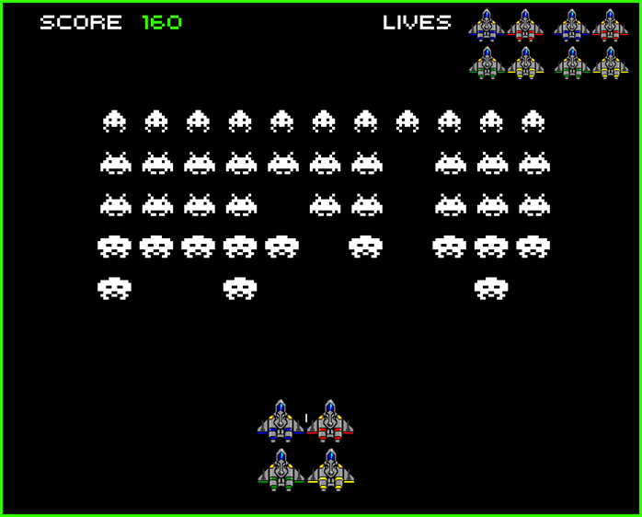

* Change Shot speed to 0.0
* Set Shot X to Ship X
* Set Shot Y to (Ship Y + 15)

Else:

* Set Alien visibility to False
* Change Shot speed to 0.0
* Set Shot X to Ship X
* Set Shot Y to (Ship Y + 15)
* Set Score to Score + 10

When Shot collided with Alien:

When Shot fired set Shot speed to 10 and set heading to 90.0